Chilliwack Whitewater Slalom Training Camp
July 7-9
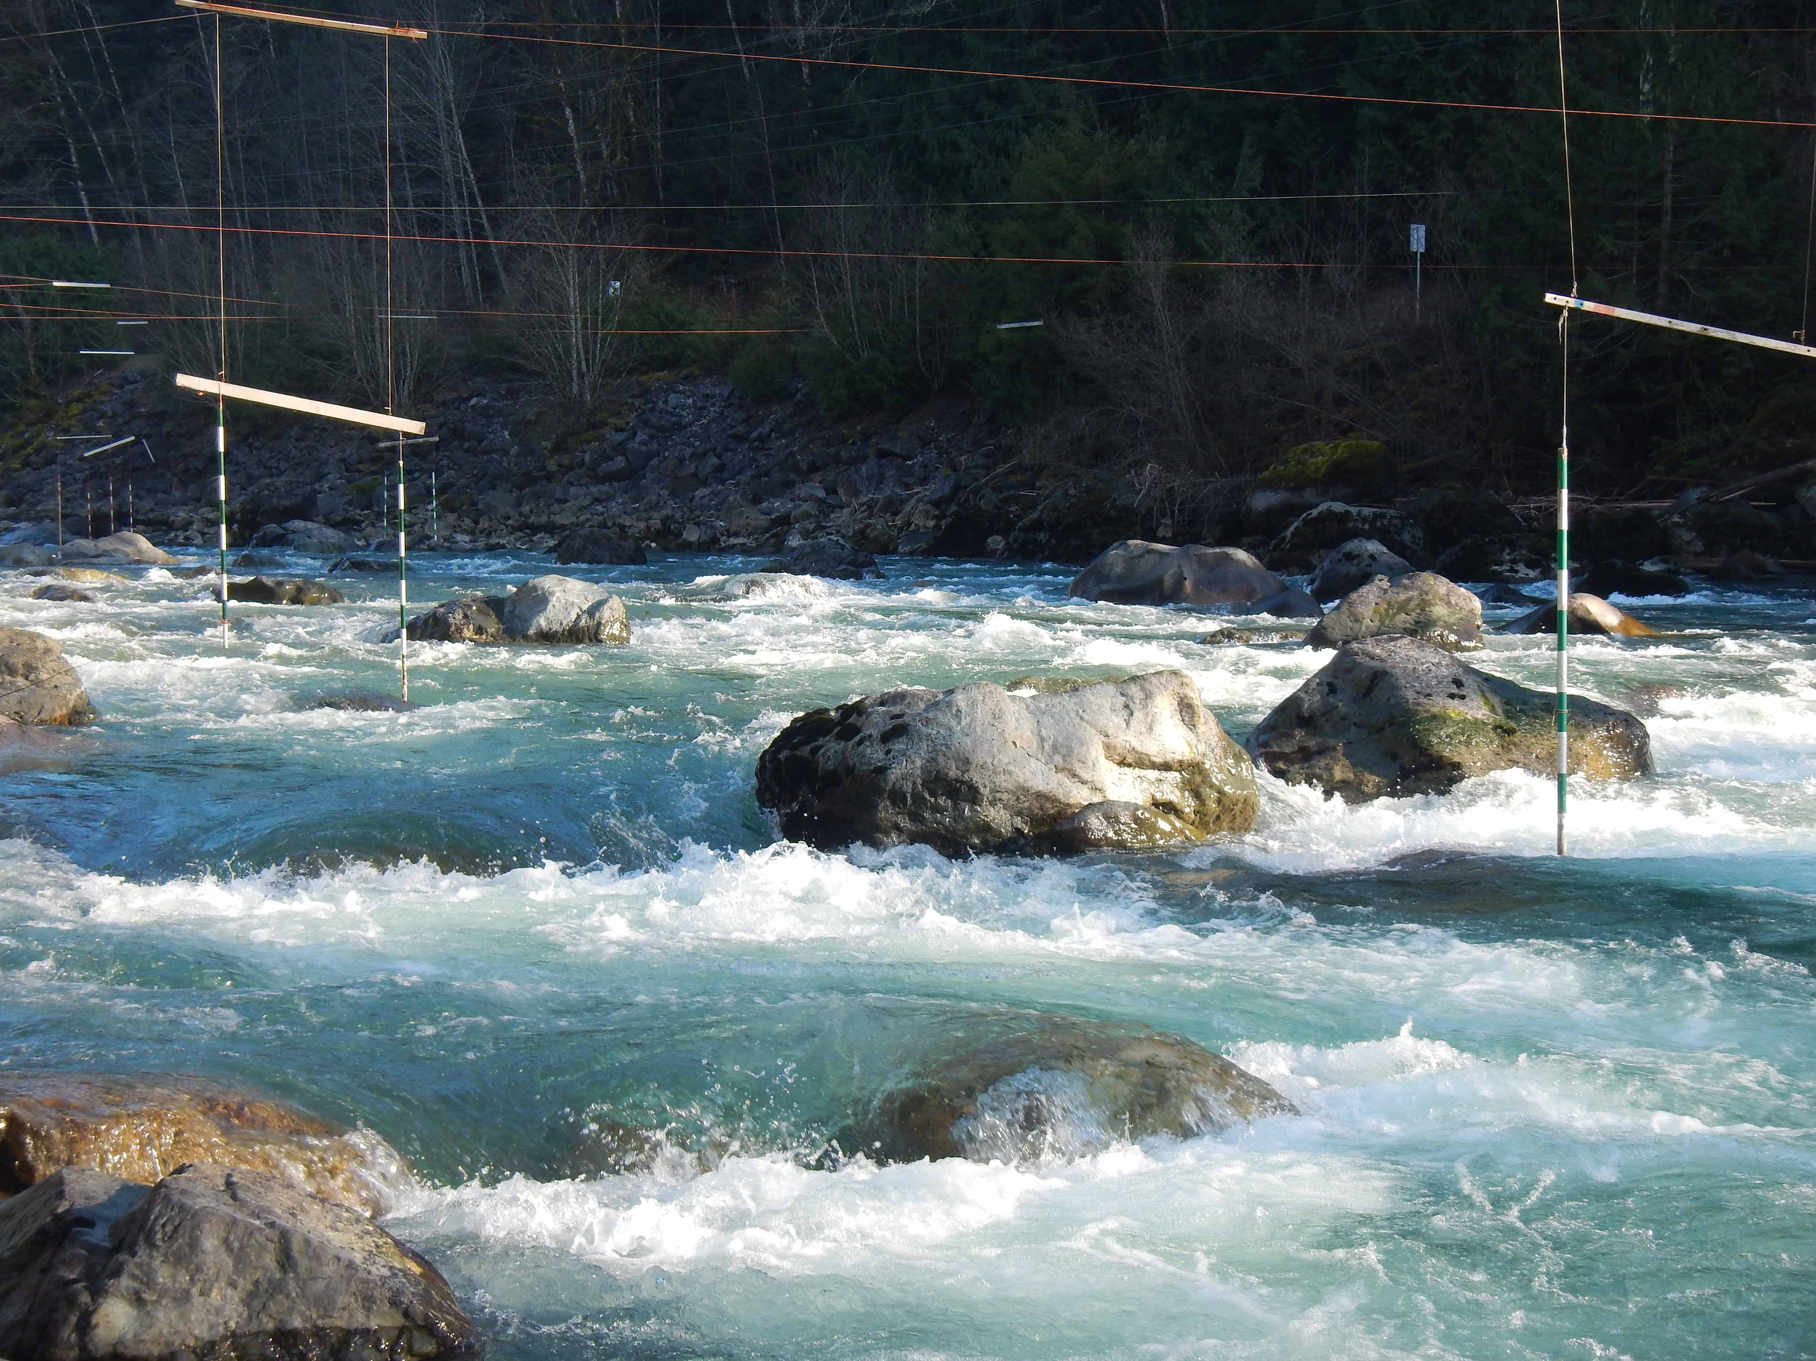
Announcing a training camp on the Chilliwack River at Tamihi Rapids near Chilliwack BC. Several of us are hoping to get there on Thursday to organize the gates and there will be coaching and free paddling sessions on Friday, Sat and Sunday. The river is currently high (1.8 meters), but we hope the river will drop to more like 1.3-1.5 meters by that weekend. See the gauge at: http://wateroffice.ec.gc.ca/report/real_time_e.html?stn=08MH103

We will have coaching by US team member Charlie Kieft and videography and timed runs by David Johnson and Charlie each day. The hope is to have a small but competitive race on Sunday. If you are interested, be certain you contact David Johnson at: johnsoda7@gmail.com at least one week before the camp. We need to know the level of interest and how to schedule sessions in advance. Less favorably phone him at 503 720 4854. Suggested fees for adults: $25 per day (one or two sessions per day). No fees for kids or teens.

